Mail Merge Instructions for User ID Distribution

NOTE: This step must be completed no later than 12/13/21
Please use the attached template along with log in instructions to provide your associates with their username and important information about UKG. This is a template. Feel free to customize, update the logo, etc. based on any unique requirements you have at your club.
Mail Merge Instructions:
- Save the sample letter to your computer
- Customize the letter to your operation
  - Most clubs are biweekly (12/18/2021). If you are in NY or RI you are on a weekly cycle (12/25/2021). If you have questions on what cycle you are on please reach out to your payroll contact.
  - Add your club specific instructions on clocking in
- Run Your “UKG Username” Business Intelligence Report
  - For information on how to run a Business Intelligence report, see the tutorial below
- Download as Excel data and save this to your computer
- Sort the data in the order you want the documents to print with the merge
- Save the file to your computer
- Follow the mail Merge wizard features in Word
  - Open the letter
  - Select the “Mailings” tab
  - Select “Start Mail Merge”
  - Select “Step-by-Step Mail Merge Wizard”
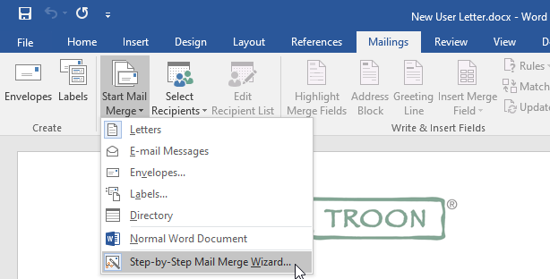

Step 1: Select “Letters” as the document type
Step 2: Select Starting document: “Use the current document”
Step 3: Select Recipients: “Use Existing list”
Step 4: Select browse and find the UKG Username file that you saved in the above step 6,
Step 5: Add the fields into the letter.
- To do this you will highlight the place holder fields (ex. Highlight [Full Name]), next on the right-hand side select “More Items”. Click on the “Full Name” in the list and select insert. Repeat this step for all placeholder fields.
Step 6: Preview the letter

-Read through the letter and verify that all of the placeholder fields are filled in with the correct information
Step 7: Complete and print your mail merge

- Provide letters on your go live date

